**INTI International College Penang School of Engineering and Technology**

**3+0 Bachelor of Science (Hons) in Computer Science, in collaboration with Coventry University, UK**

**3+0 Bachelor of Science (Hons) in Computing, in collaboration with Coventry University, UK**

**Coursework cover sheet**

**Section A - To be completed by the student**

|  |  |
| --- | --- |
| Full Name: MAH CHUN-HOE | |
| CU Student ID Number: P22014268 | |
| Semester: 1 | |
| Session:  **August 2022** | |
| Lecturer:  **Nadhrah Abdul Hadi (nadhrah.abdulhadi@newinti.edu.my)** | |
| Module Code and Title:  **4067CEM Software Design** | |
| Assignment No. / Title:  **Continuous Assessment** | % of Module Mark:  **50** |
| Hand out Date:  **6th September 2022** | Due Date:  **Task 1: 30 September 2022, by 11.59pm.**  **Task 2: 18 November 2022, by 11.59pm**  **Task 3: 4 November 2022, by 11.59pm.**  **Task 4: 4 November 2022, by 11.59pm.**  **Task 5: 4 November 2022, by 11.59pm.** |
| Penalties: No late work will be accepted. If you are unable to submit coursework on time due to extenuating circumstances, you may be eligible for an extension. Please consult the lecturer. | |
| Declaration: I/we the undersigned confirm that I/we have read and agree to abide by the University regulations on plagiarism and cheating and Faculty coursework policies and procedures. I/we confirm that this piece of work is my/our own. I/we consent to appropriate storage of our work for plagiarism checking.    Signature(s): ________________________ | |

**Section B - To be completed by the module leader**

|  |  |  |
| --- | --- | --- |
| Intended learning outcomes assessed by this work:  1. Understand and apply appropriate concepts, tools and techniques to each stage of the software development  2. Understand and apply design patterns to software components in developing new software  3. Demonstrate an understanding of project planning and working to agreed deadlines, along with professional, interpersonal skills and effective communication required for software production  5. Demonstrate an awareness of, and ability to apply, social, professional, legal and ethical standards as documented in relevant laws and professional codes of conduct such as that of the Malaysian National Computer Confederation. | | |
| Marking scheme | Max | Mark |
| 1. User Story Mapping 2. Setting up a GitHub Repository 3. Creating a Class diagram and design pattern selection 4. Creating a Prototype User Interface and Usability Testing 5. Discuss the ethical issue related to the software | 20  10  30  20  20 |  |
| Total | 100 |  |

Task 4 – Prototype User Interface & Usability Testing

Prototype User Interface: <https://balsamiq.cloud/swstyqi/pcgmo3p>

# Two major functions

# The two major functions of the Student Buddy System are finding a buddy and the different ways on how buddies would interact with each other in the system. These two functions were chosen as the major ones because this system was designed to help out students who have just enrolled into a new school and are unfamiliar with the environment. These kinds of students will mostly be socially awkward in the first few days in school. With the help of the Student Buddy System, students would be able to easily make friends and interact with them. This way, students will have someone to reach out for help when they are in need.

# The first major function is how users find a buddy with the Student Buddy System. After the users sign up and create their profile, they will be taken to the homepage. Users will be able to click on the search button located at the bottom of the interface. After that, users can search for buddies or find them by different categories. Buddies will first be shown with their brief details like their name, age, interests and hobbies for users to determine which buddy is more suitable to them and the program they are enrolled in. Three buttons are there for users to either send a message request to the buddy, add the buddy or to learn more about the buddy. A short description of the buddy will be shown if users click on the more button, his or her social media handle will also be shared to the user. The buddy will receive a message request when the user clicks on the add button. He or she has the option to accept or reject the buddy request.

# Next up, it is the different methods on how buddies interact with each other. After adding a buddy, the user can first send a message in the personal chat to just to get the ball rolling. They can set a nickname for their buddy, create events for gatherings, send an image or documents to them, make a voice or video call to them, or even share their real-time location or location of a place they are going to have a gathering. Users can make a group chat if they want to have the option to discuss with two buddies or more about the same topic simultaneously. Users can also share their screen during video calls with their buddies if they have anything to discuss that requires sharing their screen. For example, teaching programming subjects or guidance on using a system. Furthermore, users also can view or add stories to their profile. Stories are images or videos captures in a vertical format to show what users are up to at the current moment. Stories will disappear after 24 hours have passed. Other than that, if buddies want to spend an even more fun and quality time with each other, they could also play the mini games available in the system. By interacting with mini games, buddies could build an even stable relationship between each other.

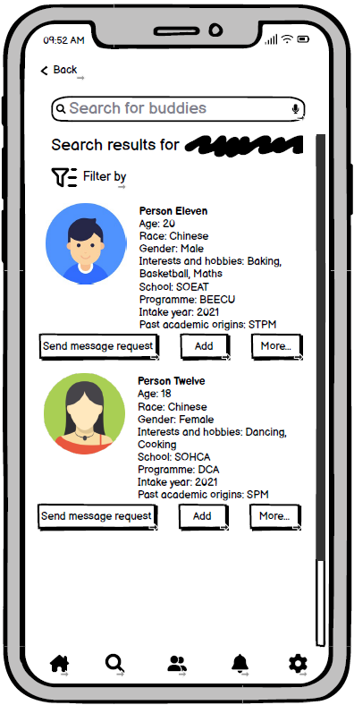 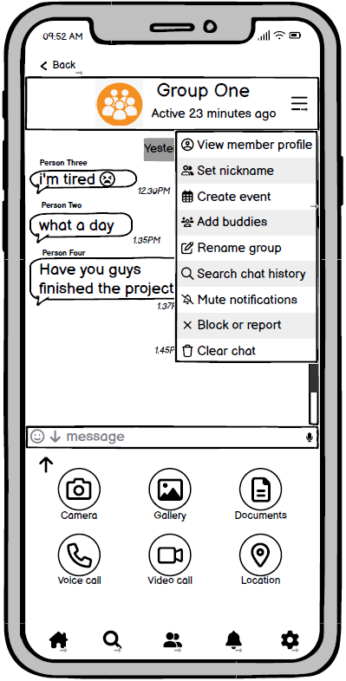

**Figure 1: The interface showing the search results and the details shown for each buddy when searching**

**Figure 2: The interface showing the group chat between multiple buddies and the hamburger menu showing multiple options**

Usability Testing Questions:

Usability Testing Questions are questions in research to further understand on how well users interact with a product or system that is going to be launched in the market soon. From answering the questions, researchers are able to know whether users are satisfied with the system or not and whether any improvement is needed to the system before launching to the public.

|  |  |  |  |  |  |  |
| --- | --- | --- | --- | --- | --- | --- |
|  | **Usability Testing Questionnaire** | **Strongly disagree** | **Disagree** | **Neutral** | **Agree** | **Strongly agree** |
|  | **Questions** | **1** | **2** | **3** | **4** | **5** |
| 1 | Overall, I am satisfied with how easy it is to use the system |  |  |  |  |  |
| 2 | It is easy to navigate throughout the system |  |  |  |  |  |
| 3 | It was easy to use this system for the first time |  |  |  |  |  |
| 4 | I found the system attractive |  |  |  |  |  |
| 5 | I was able to complete major tasks easily in the system |  |  |  |  |  |
| 6 | I find it easy to make friends in a new environment with the help of this system |  |  |  |  |  |
| 7 | I was able to go back to the previous page from the current one smoothly |  |  |  |  |  |
| 8 | The system could help with my academic needs |  |  |  |  |  |
| 9 | The information of buddies was clear and simple |  |  |  |  |  |
| 10 | It is easy to find the information I needed |  |  |  |  |  |
| 11 | The placement of buttons and icons in the system were not messy |  |  |  |  |  |
| 12 | The interface of the system is user-friendly |  |  |  |  |  |
| 13 | Those who seldom use social media applications will find it easy to use |  |  |  |  |  |
| 14 | I like using the interface of this system |  |  |  |  |  |
| 15 | The system has all the functions and features I expect it to have |  |  |  |  |  |
| 16 | The system alerts were straightforward and clear |  |  |  |  |  |
| 17 | I would use this system frequently |  |  |  |  |  |
| 18 | Overall, I am satisfied with this system |  |  |  |  |  |

**Table 1: Usability Testing Questionnaire**